Assignment 5

Map:
The values in the .yaml file are define in the following way:
image: stdrMap2.pgm
- Refers to the name of the .pgm file the contains the picture of the map
resolution: 0.050000
- as the name implies, it descripes the resolution of the map
origin: [-100.000000, -100.000000, 0.000000]
- the origin of the map, which is the lower left corner descriped as (x,y,yaw)
negate: 0
- whether to reverse the occupied with free spaces color
occupied_thresh: 0.65
- the intensity of the black color (occupied area)
free_thresh: 0.196
- the intensity of the white color (free area)
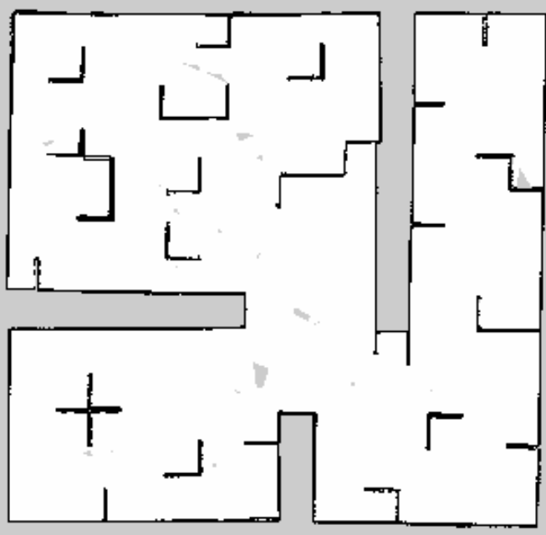

Odometry reading:

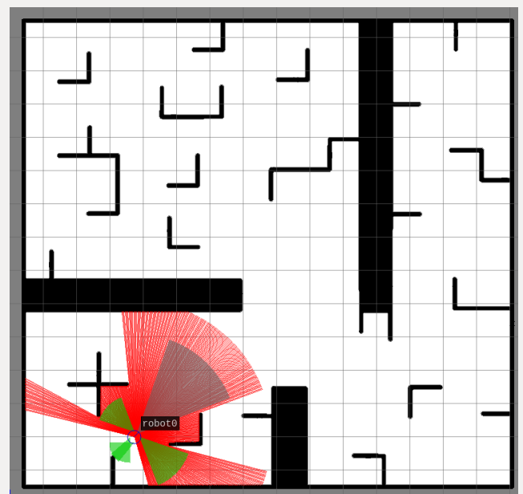
First pose:
position:
x: 3.749478974
y: 2.0
z: 0.0
orientation:
x: 0.0
y: 0.0
z: 0.391315972906
w: 0.9202563824

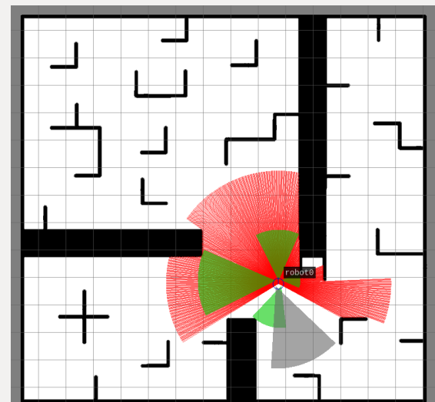
Second pose:
position:
x: 9.75130197204
y: 4.79909345068
z: 0.0
orientation:
x: 0.0
y: 0.0
z: 0.71653377421
w: 0.697552399764

Third pose:
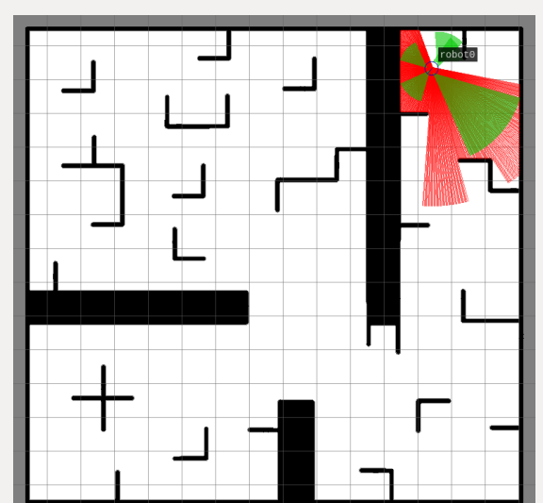
position:
x: 12.4399995804
y: 13.3599996567
z: 0.0
orientation:
x: -0.0
y: 0.0
z: 0.909296606807
w: -0.416148628317

Odometry questions:
- The map have x-coordinates( from left to right) and y-coordinates (from bottom to top).
- x+ is to the right and y+ is up.
- heading 0 is the right directions.
- the dimensions of the map is around 15x15 square meters.

